Student/Parent Handbook
2020-2021

BEACON HEIGHTS ES
6929 Furman Parkway
Riverdale, MD 20737
(301)918-8700

Dr. Lila Walker, Principal
Ms. Tracey Smith, Assistant Principal

Table of Contents

Message from the Principal 2

BHES Promise 2

BHES Mission and Vision Statements 3

PGCPS Mission and Vision Statements 3

1st Semester Virtual Learning Expectations 4-5

Instructional Materials and Software 6

Attendance 7-8

Grading and Reporting 9

Meal Services 10-11

Communication 11-12

Class Dojo 12

School Support Services 13

Community School Information 14

Parent Teacher Organization (PTO) 15

Parent Support 16

References:
Student Code of Conduct - English
Attendance AP 5121

Student Code of Conduct - en espanol
Fall 2020 Draft Reopening Plan | Spanish | French (updated August 14)

Message from the Principal

Dear Beacon Heights Students and Families,

Welcome to Beacon Heights Elementary School. We believe our school is a very special place and that your children will find it a rich and rewarding environment in which to grow and learn. We are proud of many things at BHES: sound leadership, dedicated and caring teachers, academic achievement, and opportunities in the arts, a multilingual student body, and involved parents who focus on their children’s education. As principal, I am proud to be a part of the excellence established at Beacon Heights Elementary School. We will continue to excel in all areas.

We wish you and your child a most successful and happy school year,

Dr. Lila Walker, Principal

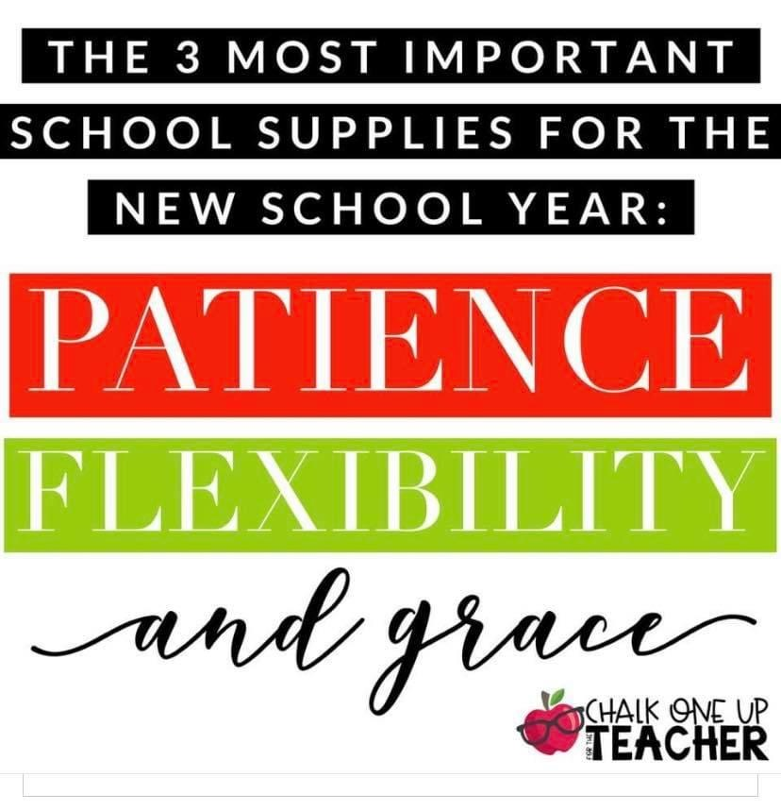

The Beacon Heights Promise

I will be respectful.

I will be responsible.

I will be ready to learn every day!

I can learn, I will learn!

The Prince George's County Board of Education does not discriminate on the basis of race, color, national origin, sex, disability, or age in its programs and activities and provides equal access to designated youth groups.

Vision Statement

We choose to have an atmosphere of respect for individual differences and community values built on creating a challenging learning environment in Science, Technology, wRiting or Robotics, Engineering, Arts, and Math, which maximizes individual potential and ensures students are well-equipped to meet the challenges in the world around them.

Mission Statement

Our mission at BHES strives to create a school atmosphere that makes environmental sustainability a priority. Utilizing the resources already set in place, we as a school will work towards integrating the STREAM curriculum so that it reaches across disciplines and age levels. Students will be encouraged to meet academic challenges with enthusiasm, building confident and creative builders of an ecologically and environmentally sound earth.

PGCPS Vision Statement
PGCPS will be a GREAT school system recognized for providing education services which ensure that every student in our diverse school district graduates ready for college and careers in a global society.

PGCPS Mission Statement
To provide a great education that empowers all students and contributes to thriving communities.
- Students are our priority and all students can achieve at high academic levels.
- Families, students, and educators share the responsibility for student success.
- High expectations inspire high performance.
- All staff share the responsibility for a safe and supportive school environment contributing to excellence in education.
- The support of everyone in our community is essential to the success of our schools and students, and this success enriches our community.
- Continuous improvement in teaching, leadership, and accountability is the key to our destiny.

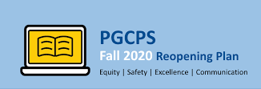
1st Semester Virtual Learning Expectations
August 31, 2020 - January 29, 2021
Students are expected to be in attendance for class daily and present for each session. Click the link above to review the completed reopening plan.

Prekindergarten
The distance learning schedule for early childhood students is both synchronous and asynchronous. During the times where there is no synchronous distance learning instruction, children will use their devices to work on age-appropriate apps including, but not limited to, Waterford, Hatch Ignite and SeeSaw with access to themed at-home projects. Teachers will incorporate planned cognitive transitions throughout the components of the day as children change from one activity to another. It is expected that transitions will take longer at the beginning of the year. As children become adjusted to daily routines, cognitive transitions should take less time and run more smoothly.

Elementary
Full Distance Learning Model - In a full distance learning model, students will receive two to four live synchronous lessons per week in reading/English language arts and mathematics, and one or two live synchronous lessons per week in science and social studies. Classes for health, physical education, music and art will rotate daily. Students will receive one lesson per week for each of these classes. Live lessons may be recorded for viewing at a later time.
Teachers will provide small group instruction to three to four student groups throughout the week for both reading and mathematics. Students not participating in small group instruction will have independent practice. Wednesdays will be used for additional small group instruction as needed. Within the distance learning models, support for English Learners (ELs) and students with disabilities will be provided by classroom teachers and certified specialists (e.g., ESOL teachers, special educators) on a regular schedule. During distance learning live lessons, ELs and students with disabilities should join breakout sessions with their ESOL teacher or special educator during a portion of the instructional block. Small group instruction for enrichment or intervention will be provided on Wednesdays as needed or documented by an IEP, EL plan, or 504 plan.

Virtual Learning Etiquette:
- All students should show respect for all people at school. This respect can be demonstrated by the way we act towards others and the way we speak.
- All students should show respect for materials and supplies (technology, textbooks, library books, etc.).
- Accept responsibility to log in to online learning prepared, on time, and be ready to learn.
- Students should set up an appropriate area to work and observe the proper dress code - the same as you would coming to the building (no lying in bed, wearing pajamas, eating, etc.).
- Cooperation should be shown as we work together in small or large groups; taking turns is important and needs to be developed.
- We use proper language and good manners—inappropriate language is unacceptable.

Monitoring of students for distance learning via principal and Professional School Counselor; for notifications of inappropriate website visits, parent contact will be made directly to the home.
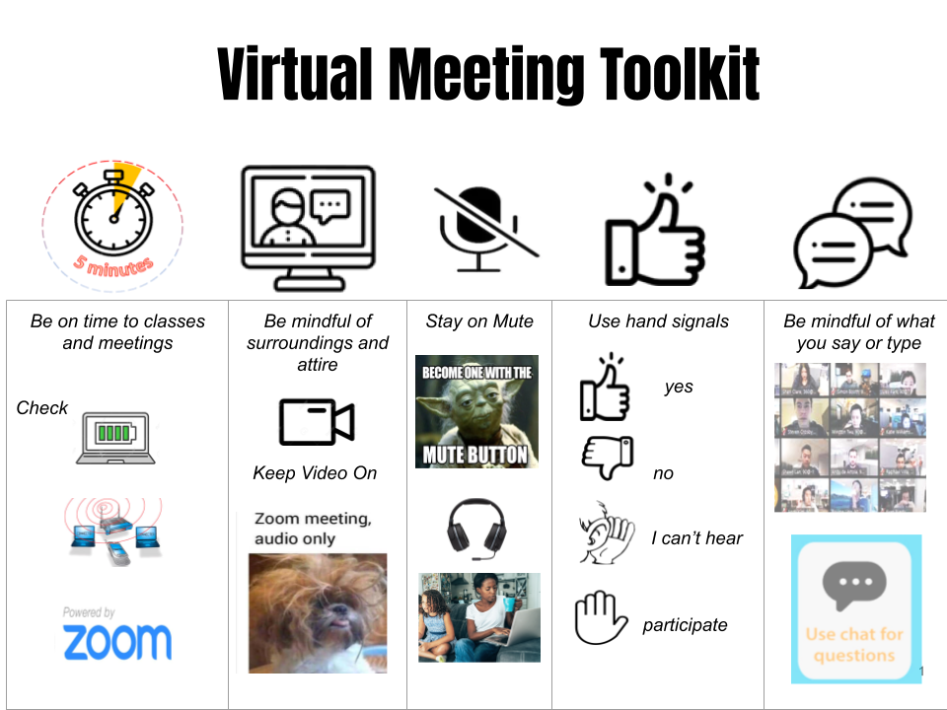
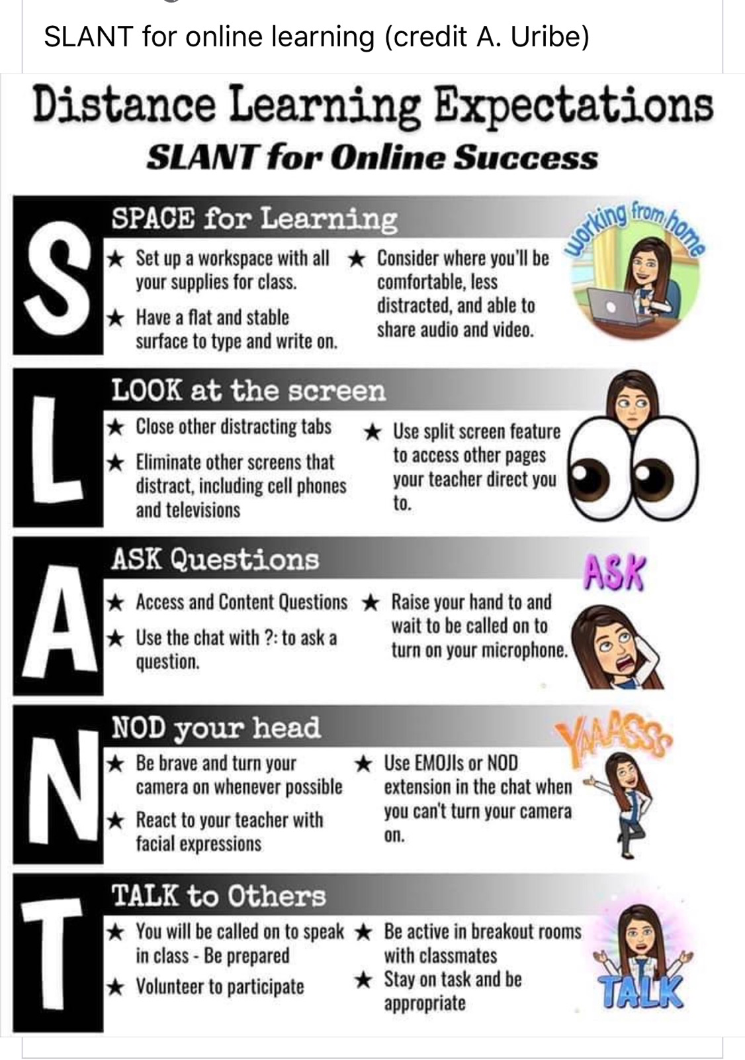
Instructional Materials and Software
Google Classroom:
Google Classroom is a digital platform that streamlines the distribution and collection of resources and assignments between teachers and students.
Clever:
Clever is a service that brings all digital tools and textbooks into a secure portal for access by teachers and students.
Osmo:
Osmo merges tactile exploration with innovative technology, actively engaging children in the learning process.
HATCH:
HATCH prepares early learners for success by creating play-based technologies that engage and instruct children while providing teachers with data and curricular experiences to help each child succeed.
All students will have access to instructional materials for use at home during distance learning. Each student will receive instructional materials based on his or her grade level and/or course of study. Materials may include, but not limited to:
- hard copy of textbook (if textbook is not digital)
- musical instrument
- art supplies
- assistive technology devices and adaptive equipment (students with accommodations)
- consumable books
- digital device (for students who never received a device)
- headphones for text-to-speech (students with accommodations/interventions)
- literature specific to content
- manipulatives
- non consumable textbooks
- novels
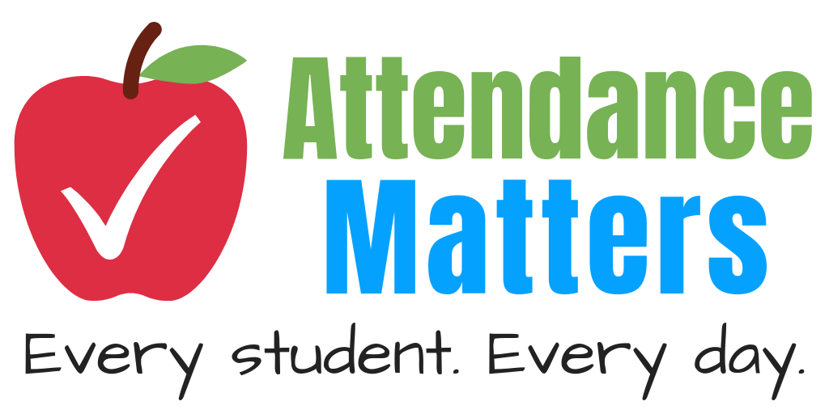
Attendance
Daily Attendance
Prince George’s County Public Schools (PGCPS) continues to follow the state and local guidance in collection of student and teacher attendance. There is currently a procedure in place to identify the process in which attendance is both collected and reported for both students and teachers. PGCPS is responsible for identifying, collecting and transmitting data to local, state and federal agencies for purposes of compliance, accountability and school system funding for student attendance. Strong monitoring of systems, implementation of a streamlined process, and using objective and accurate data related to attendance collection is crucial. Physical and virtual attendance of staff and students will be collected in the 2020-2021 school year and daily attendance procedures will be communicated so all stakeholders know PGCPS’ definition of being considered present.
Distance Learning Instruction: Elementary Schools
For all distance learning platforms, students not present on days live instruction occurs will be considered absent.
On days when students are unable to attend scheduled classes due to illness, parent work schedule, and child care; parents must communicate the reason for the student’s absence via email to the student's classroom teacher. All work assigned during the student’s absence remains required for submission. Live recordings and student assignments will be made available to students via Google Classroom.
During distance learning only, technical issues such as broken equipment or internet outages must be immediately communicated to the student’s teacher and designated school staff so support can be provided as soon as possible.

Elementary Schools
Teachers will take attendance at the beginning of each day in SchoolMax. Attendance will be reviewed again after lunch to ensure students return virtually and are accounted for. In the event a student does not return for the afternoon, the student should be recorded as attending school for a ½ day and contact made with the home to ensure the student is safe.
For Pre-K - third grade students who are unable to check in during live instruction, parents must ensure that the check in is completed before the next instructional day. If parents are unable to check in that day, please contact your child’s teacher via email so assistance can be provided.
Student attendance for Wednesday instruction will occur as follows:
A student will be counted as present, using code “Distance Learning” in our SchoolMax system, if the student does one or more of the following:
○ Submit an assignment to one of their teachers;
○ Engage in synchronous instruction or tutoring with an PGCPS teacher;
○ Meet online with a PGCPS teacher or service provider; or
○ Complete work in our supplemental online education tools where applicable (i.e. DreamBox, i-Ready and iRead)

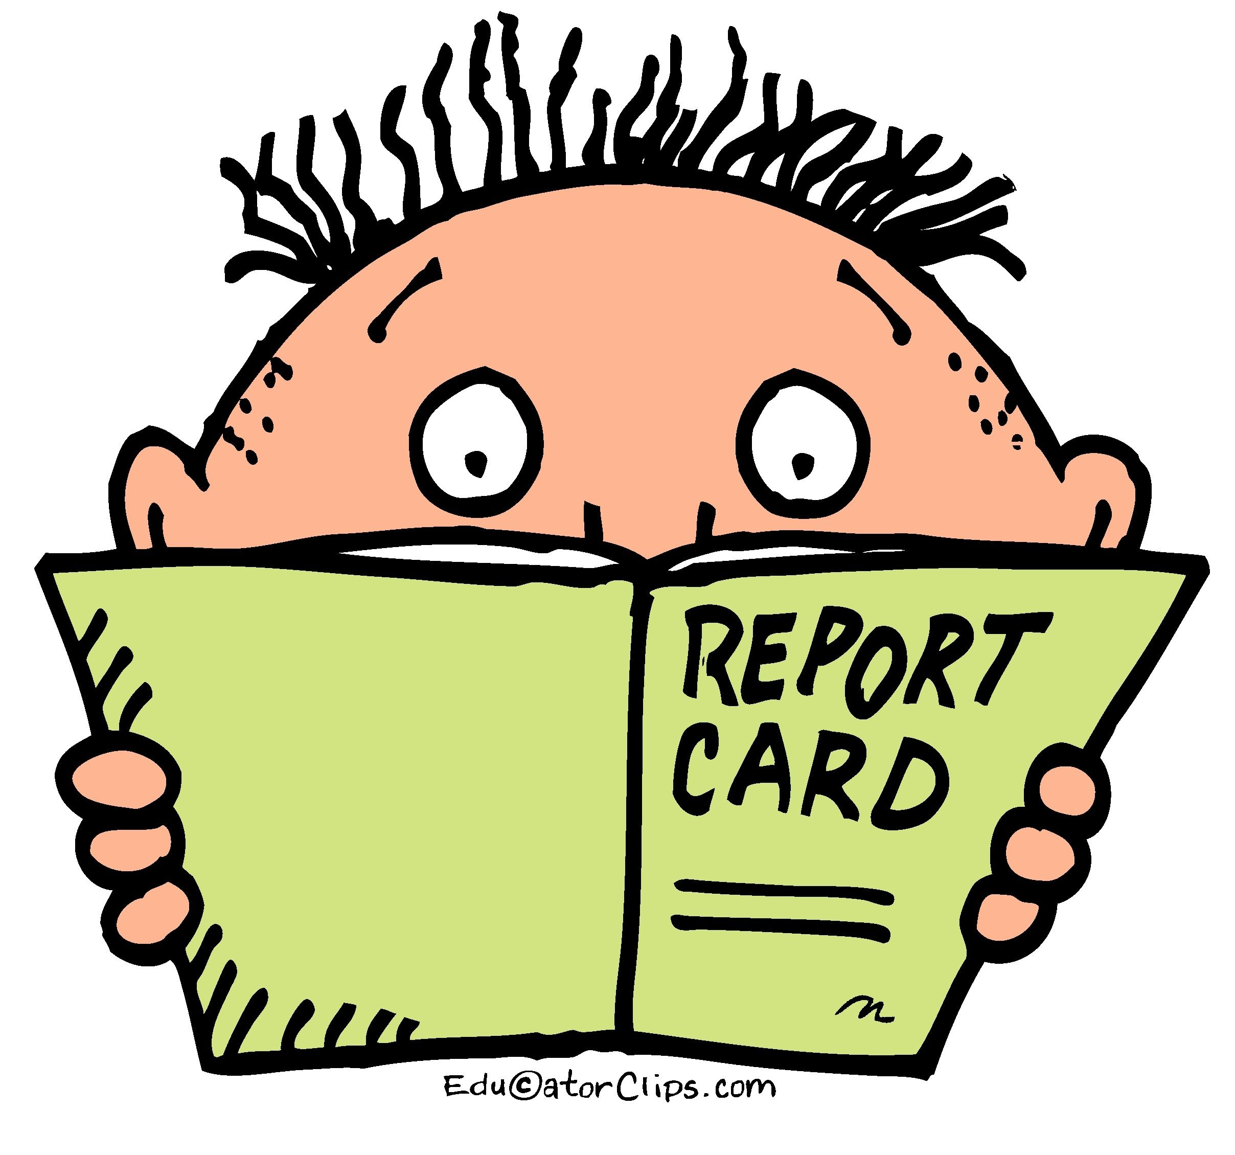
Grading and Reporting
Prince George’s County Public Schools (PGCPS) is committed to providing our students with an educational program based on instructional practices that are rooted in educational research and support student achievement. To support these efforts and establish a system where assignments and assessment both inform and drive instruction as well as provide an accurate measure of a student’s academic achievement, we will incorporate an equitable grading practice in every content area to ensure all learners’ academic success is measured with fidelity.
A systemic grading procedure provides guidance to administrators and teachers in the implementation of the grading and reporting systems to be used in prekindergarten, kindergarten, and Grades 1 through 12 in all elementary, middle, and high schools and centers in Prince George’s County Public Schools. As defined in COMAR (Code of Maryland Regulations) 13A.03.02.08, each local school system shall develop a written policy on grading and reporting. The PGCPS grading procedures have been developed according to COMAR regulations and outline a process so that all students can learn and achieve at high levels, rigorous performance standards and achievement standards are embedded as essential components of developing and delivering quality instruction, and regular assessment is an important component of an effective teaching and learning environment and an important tool in measuring students’ learning. School-based administrators, teachers and students will be familiar with procedures to ensure that grading and reporting policies are applied consistently within their school for hybrid and virtual learners.
Teachers will collect a minimum of two grades per week for elementary/middle/high (per period/class) depending on the number of meetings/periods (please see Administrative Procedure 5121 for guidance).
PGCPS’ Grading Administrative Procedure 5121 was updated to include language geared toward expectations and updates in grading factors to include distance learning. AP 5121.1 Elementary School, AP 5121.2 Middle School, AP 5121.3 High School
Students who received an I (Incomplete) grade in any course during the fourth quarter of Spring 2020 should submit the make-up work to the school (principal or designee) where the original grade was earned. A teacher or team of teachers will review the work and initiate the grade change process as applicable. To begin this process, the parent and/or student should contact the teacher of the class or Principal of the school If a student has transitioned to another school they must contact the teacher/Principal of the school where they were enrolled in the class. Teachers will collect a minimum of two grades per week for elementary/middle/high (per period/class) depending on the number of meetings/periods (please see Administrative Procedure 5121 for guidance). Assignments will remain the same weight for class work, homework and assessments by course/grade band and will receive a letter or numerical grade.
PGCPS Grading and Reporting Policy 5121

Progress Reports and Report Cards for the 2020-2021 School Year
During the 2020-2021 school year, progress report grades and report card grades will be available in SchoolMax after every marking period. Students will be able to log into SchoolMax to view their grades at any time throughout the school year. Parents can also receive an account to access their child's grades on the SchoolMax family portal. Report cards will be printed and mailed home to all families at the end of 2nd quarter and 4th quarter. Please contact our Parent Engagement Assistant, Ms. Perez, at (301) 918-8700, to receive instructions on accessing the SchoolMax Parent Portal. Please be sure your information is up to date in SchoolMax so that you can receive communications from the school.

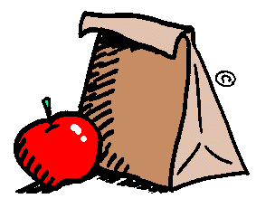
Meal Service in Full Distance Learning
Food service will operate under the National School Lunch and Breakfast program. Meals will only be provided to students enrolled in PGCPS. Students not eligible for free and reduced-priced meals will have to pay for breakfast and lunch. Food and Nutrition Services strongly encourages cashless transactions and encourages all households to deposit funds into their student account.
All Students
- All schools will serve as meal distribution sites.
- Breakfast and lunch offered.
- Meals can be picked up at the closest school in your community. Students will need to provide Name, PIN#, and the school enrolled in if they pick up a meal from a school they do not regularly attend. ● Suppers in eligible schools.
- Meals will be pre-packaged and distributed two days per week between 10:00 AM - 1:00 PM at school locations.
- Monday – meals for Monday and Tuesday
- Wednesday – meals for Wednesday, Thursday and Friday
- Meals will be distributed between 10:00 AM - 1:00 PM at designated community locations for students who live at least 1.5 miles from the nearest schools. For more information, please call the Department of Transportation support telephone number at 301-952-6570.
- Meals will be counted by eligibility status.
- Food & Nutrition Services will use school rosters to verify and record students who receive a meal.
- Parents picking up meals must have the Student PIN# or show student ID or most recent report card to verify enrollment.
FARMS Application Process:
All applications will be completed online
Communication
Effective crisis communication demands nimble collaboration between leaders with relevant expertise and clearly defined ownership of the process for crafting and distributing messages. A centralized and dedicated external communications team will help each maintain consistent messaging.
- To keep families abreast of school events, we will send out a weekly communication with updates and announcements to all families. The weekly newsletter also may be viewed on the school’s website. Please be sure we have your correct information (email address, phone number, etc.) in SchoolMax so you can receive these communications.
- A new PGCPS website via a new content management system that is more user friendly will be utilized to ensure that critical information gets seen.
- School webpages will be maintained and updated to include information on schedules, distance learning, technology, food, mental health resources, community resources, health/safety, etc.
- Reopening deliverables will be done by way of virtual videos, media tours, customized e-blasts and webpage daily updates. Communication regarding the PGCPS Reopening Plan will be shared utilizing all media resources. Additionally, a Parent University will be held virtually in order to provide support with the technical and adaptive aspects of distance learning.
- Back-to-School information will be communicated with families about immunization requirements/clinics, non-PGCPS student transfer requests, FARMS applications.
- Enrollment and Attendance Policies communication regarding student enrollment and/or attendance policy changes will be shared with all stakeholders.
- Communication strategies will be employed in order to expedite messaging via the new e-blast/messaging platform, inclusive of the synchronization of other platforms (i.e. Twitter, Class Dojo) that are utilized at the local school levels.
- There will be continuation of the use of various platforms and resources (television broadcast, interpreting services, global communication, etc.) for deliverability of information in order to ensure accessibility; close gaps for families experiencing challenges with internet access, bridge communication in various languages; and maintain fidelity to messaging/campaigns that ordinarily happen during the spring semester.

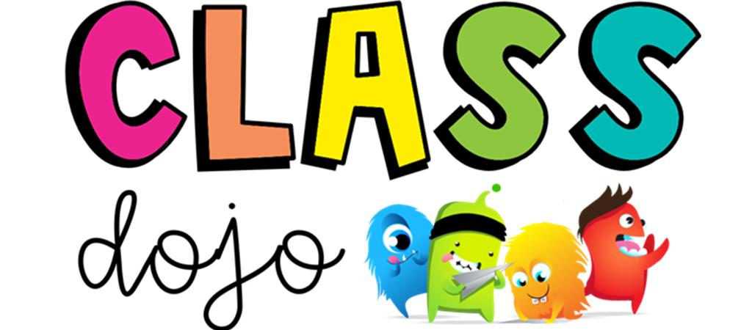

Class Dojo
Our teachers will again be using Class Dojo for recording behavior management in the classroom. Class Dojo is intended to foster positive student behaviors and classroom culture. Students earn ‘Dojo Points’ based on their classroom conduct. Teachers use Class Dojo to keep parents up to date on student progress and classroom happenings. More information on Class Dojo and how parents can connect will be provided by your child’s teacher.

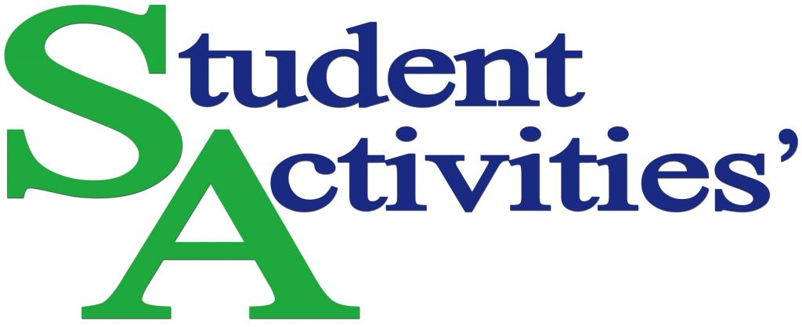

In an effort to keep staff and students safe, BHES will be utilizing virtual meeting spaces such as Zoom or Google Meet for tutoring, parent conferences, teacher office hours, student activities, organizations and extracurricular activities. Here are some of the offerings available during the SY 20/21 school year.

BHES Student Clubs
School clubs and organizations are a vital part of the total school experience and enhance the educational and social experiences of students. Here are a few of the clubs BHES will be sponsoring virtually during SY 20/21.
- Robotics
- Science Bowl
- Newton’s Thinkers
- Artists of BHES
- Chess Club
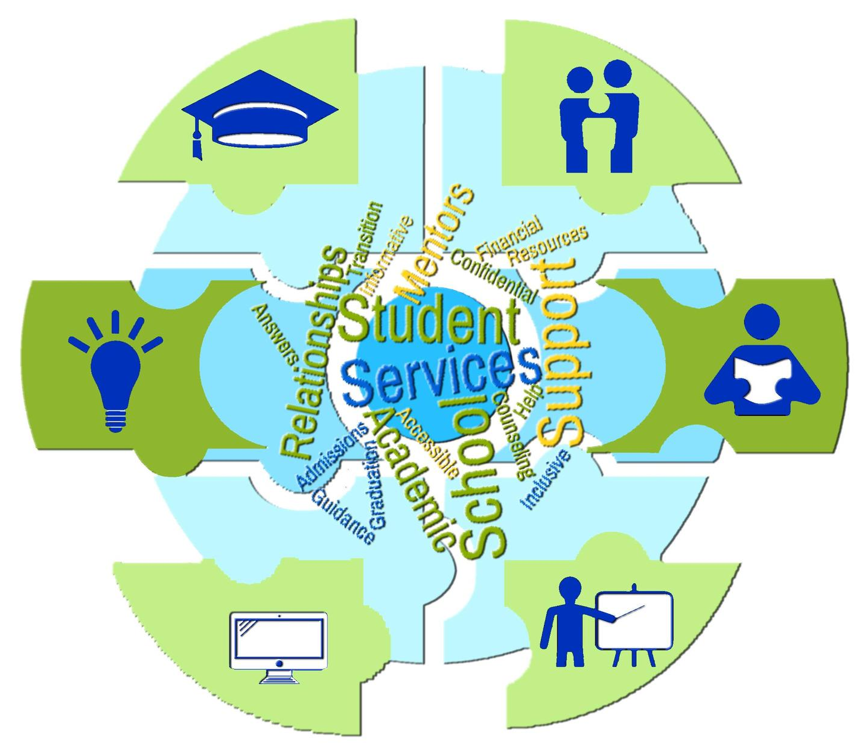
School Support Services
A variety of school support services are available to you and your child. They include: Professional School Counselor, Community School Coordinator, Parent Engagement Assistant, Special Education Resource Teachers, Media Specialist, ESOL Teachers, Speech/Language Pathologist, School Psychologist, Behavioral Therapist, Pupil Personnel Worker, and Occupational/Physical Therapist.
Feel free to contact your child’s classroom teacher or the school’s administrative staff if you have concerns on behalf of your child.
Important Telephone Numbers
Office: 301-918-8700
Fax: 301-918-8707

Community Schools Overview
The Community School Model is a national model where schools serve as the hub of the community providing both academic and social-emotional support for students and their families. As defined by the Coalition of Community Schools, “A Community School is a public school – the hub of its neighborhood, uniting families, educators and community partners to provide all students with top-quality academics, enrichment, health and social services, and opportunities to succeed in school and in life.” The goal of Community Schools is to help ensure students and their families are resilient, successful and ready to learn and are prepared to be involved in their community. PGCPS currently has a total of 45 Community Schools. Should you have any questions or are in need of support, please contact our Community School Coordinator Sasha Ledesma at sasha.ledesma@pgcps.org.

Wrap-Around Services Provided
- Extended learning time
- Before and after school
- Weekends
- Summer
- Vision and dental care services
- Expanding school-based health center services
- Additional social workers, counselors, and restorative practice coaches
- Enhancing physical wellness, including providing food for in-school and out-of-school time
- Enhancing behavioral health services including access to mental health practitioners and providing professional development to school staff to provide trauma-informed interventions
- Providing family and community engagement and supports
- Language classes
- Workforce development training
- Establishing and enhancing linkages to Judy Centers
- Enhancing student enrichment experiences
- Improving student attendance
- Additional professional development for school staff to identify students who are in need of resources

The following are ways the Office of Community Schools will virtually support students and parents:
- Community School coordinators will host Parent Academies that may cover topics/themes regarding Digital Learning 101, Literacy Learning Parties, mediation, self-care, English classes, cooking classes, physical fitness, etc.
- Community School coordinators will assist students and families with technology. Coordinate after school clubs, activities, and celebrations for the students.
- Staff will attend attendance meetings and provide ideas to the parents for improving attendance (i.e., attendanceworks.org).
- Connect students and families with Department of Social Services, mental health providers and other internal and external stakeholders for assistance (food, clothing, shelter/rental assistance, health care, legal services, etc.)
- Provide monthly and/or bi-monthly scheduled family virtual field trips.
- Provide virtual announcements – YouTube/Facebook/Twitter/Class Dojo.
- Disburse monthly or bi-monthly electronic newsletters shared on social media platforms.
- Provide mental health therapists in all 45 schools. Mental health services are essential to creating and sustaining safe schools. Increased access to mental health services and support in schools is vital to improving the physical and psychological safety of our students and schools, as well as academic performance and problem-solving skills.
- Develop virtual programs and activities for students, parents and staff that promote learning programs which provide rigorous curriculum, meaningful teaching resources, and access to specialized programs.
- Create Parent Resource Centers located in the 45 schools to send a clear message to parents that they are very important in the education of their children. Parent Resource Centers give parents the chance to feel welcome and involved in school.

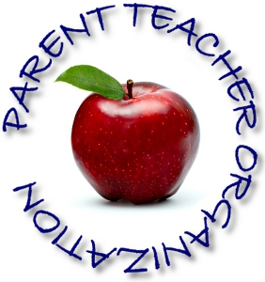
Parent Teacher Organization (PTO)
Beacon Heights ES is fortunate to have an active and supportive PTO. Financial assistance from the PTO may provide supplements to our instructional, music, physical education, art, media center, computer, and safety programs. In addition, the PTO strongly supports the continued beautification of our indoor and outdoor spaces. All parents are encouraged to show their support for the outstanding work done by joining the PTO and attending regular meetings. Every parent or guardian of a child in our school is automatically a member of our Parent Teacher Organization. We urge your active participation. We are seeking 100% support this year -it is $10 per family.

Parent Support During Virtual Learning
PGCPS heard from parents and guardians during the implementation of distance learning this past winter/spring 2020 – assistance was needed in the areas of technology, instruction, and other supports. Thus we have strategically designated locations throughout PGCPS where parents can receive assistance with technology, accessing and navigating platforms, and other troubleshooting beginning September 1, 2020. Days/Times: Tuesdays and Thursdays, 8:00 a.m. – 10:00 a.m. and 6:00 p.m. – 8:00 p.m.
Locations:
- Benjamin Tasker Middle School - 4901 Collington Road, Bowie, MD 20715
- Charles Carroll Middle School - 6130 Lamont Drive, New Carrollton, MD 20784
- Drew Freeman Middle School - 2600 Brooks Drive, Suitland, MD 20746
- G. James Gholson Middle School - 900 Nalley Road, Landover, MD 20785
- Gwynn Park High School - 13800 Brandywine Road, Brandywine, MD 20613
- High Point High School - 3601 Powder Mill Road, Beltsville, MD 20705
- Northwestern High School - 7000 Adelphi Road, Hyattsville, MD 20782
- Port Towns Elementary School - 4351 58th Avenue, Bladensburg, MD 20710 Thurgood Marshall Middle School - 4909 Brinkley Road, Temple Hills, MD 20748

There are specific milestones that determine school readiness. This resource is based on the Maryland College and Career Ready Standards and tells parents what students should know and be able to do by the end of his or her current grade. https://drive.google.com/file/d/1CN74YWVzb0IO1AWAyktQ3Vc7kgfEpbv_/view?usp=sharing

Best Practices for Parents Based on Experiences from March 2020 - June 2020
- Establish and stick to a routine (create this with your child, if applicable)
- Communicate with your child’s teacher
- Ask for help
- Do your own work while your child is participating in online schooling
- Encourage frequent breaks that may involve the outdoors
- Give yourself grace

8 Tips to Help Keep Your Child Engaged During Distance Learning: https://education.jhu.edu/2020/04/8tipsforfocus/

